Dante Freeman

CSC114

5.22.2024

Module 4, Lab 1: If Statements

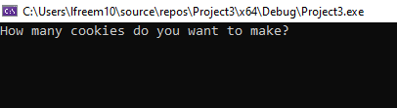

If negative number entered: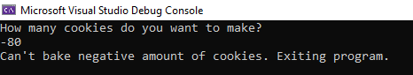

If a number of cookies that requires < 5 cups entered:

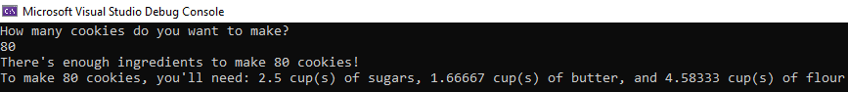

If a particular ingredient requires more than 5 cups, program indicates this:

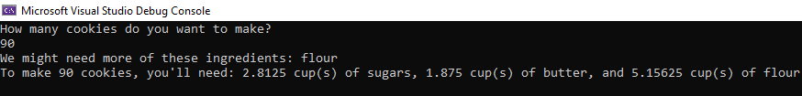

Similarly, if all ingredients over 5 cups:

